1. System Overview
The Smart Parking Lot system manages:

Vehicle entry & exit

Automatic spot allocation based on vehicle size

Real-time availability tracking

Parking fee calculation

Concurrency-safe operations for high traffic

The backend exposes APIs used by entry gates, exit gates, admin dashboards, and display boards.
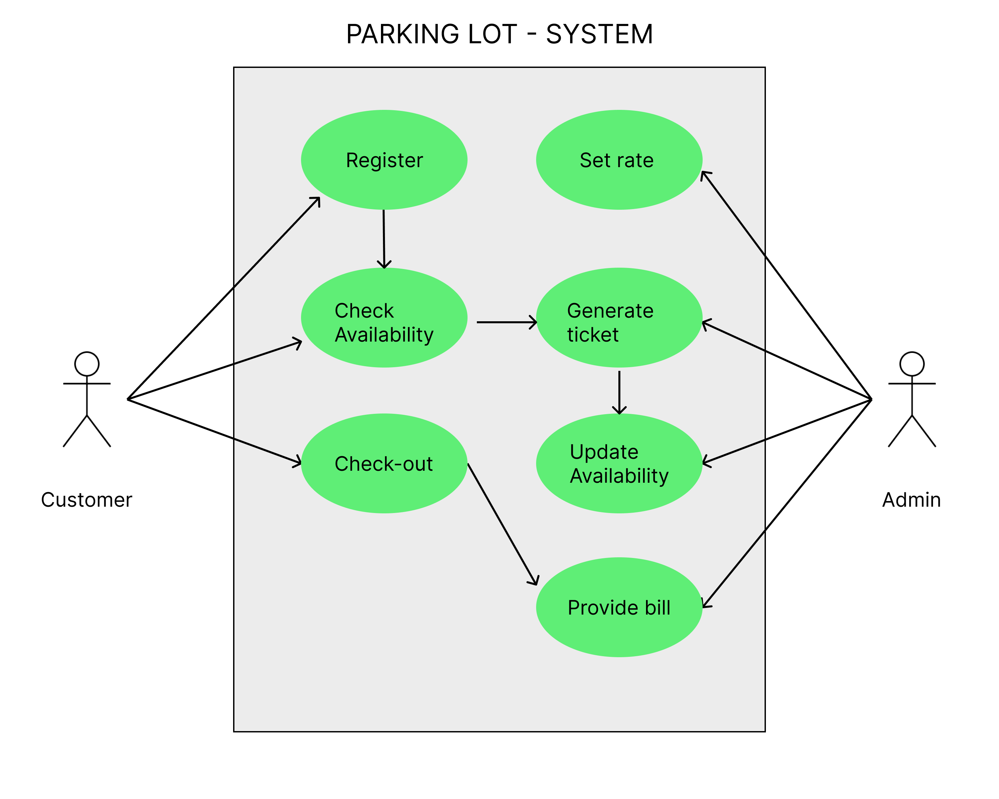
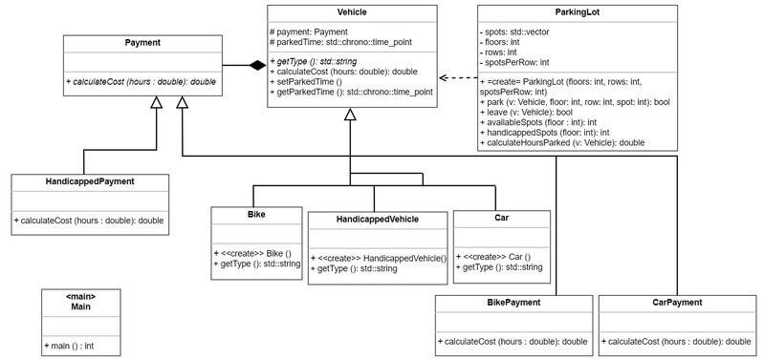
2. Core Components (LLD)
2.1 Main Services
Service | Responsibility
Entry Service | Handles vehicle check-in and spot allocation
Exit Service | Handles vehicle check-out and fee calculation
Spot Allocation Service | Finds optimal parking spot
Pricing Service | Calculates parking fee
Availability Service | Maintains real-time spot status
Transaction Service | Stores parking history
Locking / Concurrency Manager | Prevents double allocation
3. Data Model (Database Schema)
3.1 Vehicle
Vehicle
-------
vehicle_id (PK)
vehicle_number
vehicle_type (MOTORCYCLE | CAR | BUS)
3.2 ParkingFloor
ParkingFloor
------------
floor_id (PK)
floor_number
3.3 ParkingSpot
ParkingSpot
-----------
spot_id (PK)
floor_id (FK)
spot_type (MOTORCYCLE | CAR | BUS)
is_available (BOOLEAN)
3.4 ParkingTicket (Transaction)
ParkingTicket
-------------
ticket_id (PK)
vehicle_id (FK)
spot_id (FK)
entry_time
exit_time
total_fee
status (ACTIVE | COMPLETED)
3.5 PricingConfig
PricingConfig
-------------
vehicle_type
price_per_hour
4. Parking Spot Allocation Algorithm
Rules

Motorcycle → Motorcycle / Car spot

Car → Car spot

Bus → Bus spot only

Nearest floor preferred

First available spot

Algorithm (Pseudo-logic)
function allocateSpot(vehicleType):
eligibleSpots = find spots where
spot_type >= vehicleType
and is_available = true
order by floor_number, spot_id
lock selected spot
mark spot as unavailable
return spot
Optimization

Maintain in-memory index:

availableSpots[vehicleType][floor] → min-heap
5. Check-In Flow (Entry)

Vehicle arrives at entry gate

Entry Service receives vehicle details

Spot Allocation Service assigns a spot

Create ParkingTicket with entry_time

Update ParkingSpot → is_available = false

Display assigned spot to driver

ENTRY → Allocate Spot → Create Ticket → Update Availability
6. Check-Out Flow (Exit)

Vehicle arrives at exit gate

Fetch active ParkingTicket

Set exit_time

Pricing Service calculates fee

Mark spot as available

Update ticket status to COMPLETED

EXIT → Calculate Fee → Free Spot → Close Ticket
7. Parking Fee Calculation Logic
Fee Formula
Total Fee = ceil((exit_time - entry_time) in hours) × price_per_hour
Example
Vehicle | Duration | Rate | Fee
Car | 2.5 hrs | ₹50/hr | ₹150
Bike | 1.2 hrs | ₹20/hr | ₹40
8. Concurrency Handling
Problems to Solve

Two vehicles getting the same spot

Simultaneous exits updating availability

Solutions
Option 1: Database Locking
SELECT * FROM ParkingSpotWHERE is_available = trueFOR UPDATE;
Option 2: Distributed Lock (Recommended)

Redis / Zookeeper

Lock key: spot:{spot_id}

Option 3: Optimistic Locking

version column in ParkingSpot

9. Real-Time Availability Updates
Strategy

Update DB on entry/exit

Push updates via:

WebSocket

Kafka / Event Queue

Redis Pub-Sub

Event → Availability Service → Display Boards / Apps
10. API Design (Sample)
Entry API
POST /api/parking/entry
{
"vehicleNumber": "KA01AB1234",
"vehicleType": "CAR"
}
Exit API
POST /api/parking/exit
{
"ticketId": "T123"
}

